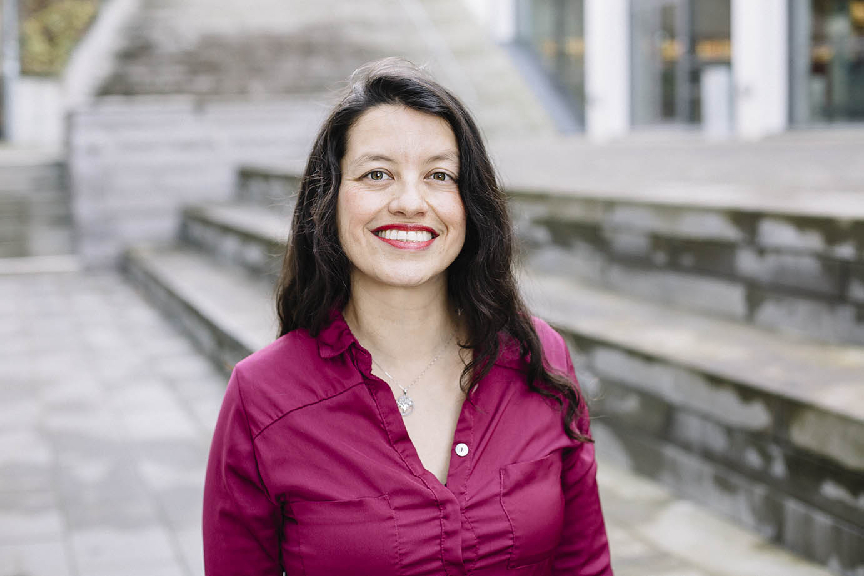 Carolina

*Telephone: +46 455385569*

*Mobile: +46 766073922*

*E-Mail:* [dcv@bth.se](mailto:dcv@bth.se)

Villamil

# SUMMARY

# AREAS OF EXPERTISE

Product design

Sustainable product development

PSS - Product Service System Innovation

Design instruction

# AWARDS

2012: **Global Swede** Swedish Ministry for Foreign Affairs for excellence in areas of innovation and entrepreneurship. Swedish Institute (SI). Stockholm, Sweden.

2009: Finalist Graphic piece in the “IV Bienal de afiches Cámara de Comercio de Bogotá.

# LANGUAGES

English - Advance

Spanish - Native

# kNOWLEDGE and Skills

Design thinking

Life Cycle Assessment

Community engagement

Context Analysis

Board Game Design

Pedagogic Material Design

3D model and animation

Graphic Design

Denny Carolina Villamil is a Colombian PhD student at Blekinge Tekniska Högskola in the Department of Strategic Sustainable Development at BTH (Sweden). She is a creative, enthusiastic, skilled and passionate designer, who has experience in the fields of industrial design and education. She has a Master in Sustainable Product Service System (PSS) Innovation, she is an energetic team member who views challenges as great opportunities and has a big commitment with the environment and the development of sustainable products and services with the focus on stakeholder’s active participation.

# Work Experience

2017 – present PhD Student

Blekinge Institute of Technology

Department of Strategic Sustainable Development

2013 – 2017 Adjunct Instructor

Politecnico Grancolombiano. Bogotá - Colombia.

Program of Environmental management.

2013 – 2017 Adjunct Instructor

2008 – 2010 Universidad Jorge Tadeo Lozano. Bogotá - Colombia.

Design and Architecture Department.

2012 – 2017 Freelance Product Brand Designer

2007 – 2010 Transtec Diseño e Ingeniería SA. Bogotá, Colombia

2008 Adjunct Instructor

Universidad Autónoma de Colombia, Bogotá - Colombia.

Industrial Design Program.

2008 Amity Intern Teacher

2006 – 2007 Mounds Park Academy, St. Paul, MN, US

Bridgewater Elementary School. Northfield, MN, US

2006 Adjunct Instructor

Universidad de Boyacá. Tunja - Colombia.

Graphic Design Program.

2005 – 2006 Product Brand Designer

Transtec Diseño e Ingeniería SA. Bogotá, Colombia

2003 – 2004 Industrial Designer

Nmdesign. Bogotá, Colombia

2002 Adjunct Instructor

UPTC Universidad Pedagógica y Tecnológica de Colombia. Duitama - Colombia.

Industrial Design Program.

# Education

2017 - present Admission to Third-Cycle Studies

Blekinge Institute of Technology, Sweden

2010 - 2012 M.Sc. Sustainable Product -Service System Innovation MSPI

Blekinge Institute of Technology, Sweden

2003 - 2004 Graduate Certificate in Multimedia Design

Universidad Nacional de Colombia, Bogotá (Colombia).

1995 - 2001 Undergraduate Degree in Industrial Design

Universidad Nacional de Colombia, Bogotá (Colombia).

# Other Courses

2015 First level in TRIZ training

International TRIZ Association. Bogota.

2011 “All just Rubbish”

Sustainability Summer School on the themes of green product design, waste and material life cycles. Food Packaging, Case study. ETH, Zurich, Switzerland

# PROJECTS

2017 – present Strategic, Tactical, and Operational Implementation of Sustainability into the Innovation Process (STOSIP) (<https://www.bth.se/eng/stosip/>)

The project’s main purpose is to support product development and manufacturing companies in integrating and implementing a strategic sustainability perspective in the product innovation process. Carolina will contribute to the research to define “Sustainable Product Portfolio” with the purpose to include sustainability in the early stage of product development process and to outline an evaluation criteria method to select the elements of a company´s Product Portfolio. Dep. of Strategic Sustainable Development at BTH.

2015 – 2016 Sustainable design and production - Guide Book

Material developed for the virtual course called “Sustainable design and production”. Developed for On-line courses at Politecnico Grancolombiano

# PUBLICATIONS

Villamil Velásquez, Denny Carolina (2016). *“Perforando territorios. Extracción, sustentabilidad, soberanía y diseño participativo en el Sur”.* Bienal Tadeísta de Diseño industrial 2014. Encuentros cardinales: acentos y matices del diseño. Universidad de Bogotá Jorge Tadeo Lozano. Bogotá. Pag. 57-75, ISBN: 978-958-725-198-2

Villamil Velásquez, Denny Carolina (2016). *“Sistemas de productos y servicios (PSS) sustentables en el contexto europeo y su relación con el diseño del sur”.* Hablemos de diseño industrial. Universidad de Bogotá Jorge Tadeo Lozano. Bogotá. Pag. 69-84, ISBN: 978-958-725-197-5