Title
Subtitle
Author

Blekinge Institute of Technology
Licentiate Dissertation Series No. 2023:??
Title
Subtitle
Author
Licentiate Dissertation in ?????????????????
Department of ???????????????????
Blekinge Institute of Technology
SWEDEN

Copyright pp [x-xx] [your name]
Paper 1 © Publisher
Paper 2 © Publisher
Paper 3 © Publisher
Paper 4 © by the Authors (Manuscript unpublished)

Blekinge Institute of Technology
Department of ?

Blekinge Institute of Technology Licentiate Dissertation Series No. 2023:??
ISBN xxx-xx-xx-x
ISSN 1650-2140
urn:nbn:se:bth-?????

Printed in Sweden by Media-Tryck, Lund University, Lund 2023

Dedication (remove both this and next page if you don´t want it)

Abstract
Usani alit qui doluptiatet est minihitios ut doloritatiis mod unt ventemp ossus, odionecta denimus ma cuptati sint et molendit vellor rem quunt.
Ditin eius reped qui quiatur audam exere possunt doloressi rem reicatem id que necabo. Obis ene nostotatum ime volo inullaborati untibus, optasse erum re, quis que doluptae nonsequam qui dolupta turibea voluptatum ut doluptatint, endia delit alique verferatium es venimillab ipit explit molende nimpores et etur? Quid erepudit lamus, con nusamus, iliquae. To quidunt.
Onectia voluptat fuga. Est rempel intem quibus, ut vent, volores quibus ullacitatur? Quiatur, temporrum volupta tendam as dolorrum faccae ium remporibus poratem nos explaboriam faceseditate volut alicit que consed untiore earuptium quo ipic te labo. Et etum estet omnihil lorepta tibernat as earit es mostia et quam reptu

Acknowledgements
Usani alit qui doluptiatet est minihitios ut doloritatiis mod unt ventemp ossus, odionecta denimus ma cuptati sint et molendit vellor rem quunt.
Ditin eius reped qui quiatur audam exere possunt doloressi rem reicatem id que necabo. Obis ene nostotatum ime volo inullaborati untibus, optasse erum re, quis que doluptae nonsequam qui dolupta turibea voluptatum ut doluptatint, endia delit alique verferatium es venimillab ipit explit molende nimpores et etur? Quid erepudit lamus, con nusamus, iliquae. To quidunt.
Onectia voluptat fuga. Est rempel intem quibus, ut vent, volores quibus ullacitatur? Quiatur, temporrum volupta tendam as dolorrum faccae ium remporibus poratem nos explaboriam faceseditate volut alicit que consed untiore earuptium quo ipic te labo. Et etum estet omnihil lorepta tibernat as earit es mostia et quam reptur?

List of Papers

Paper I
Sjölin K., Rayner M., Purhagen J. and Sjöholm I. (2022) Usani alit qui Onectia voluptat fuga. Est rempel intem quibus, ut vent, volores quibus ullacitatur? Quiatur, temporrum volupta tendam as dolorrum faccae ium remporibus poratem

Paper II
Sjölin K., Rayner M., Purhagen J. and Sjöholm I. (2022) Usani alit qui Onectia voluptat fuga. Est rempel intem quibus, ut vent, volores quibus ullacitatur? Quiatur, temporrum volupta tendam as dolorrum faccae ium remporibus poratem

Paper III
Sjölin K., Rayner M., Purhagen J. and Sjöholm I. (2022) Usani alit qui Onectia voluptat fuga. Est rempel intem quibus, ut vent, volores quibus ullacitatur? Quiatur, temporrum volupta tendam as dolorrum faccae ium remporibus poratem

Paper IV
Sjölin K., Rayner M., Purhagen J. and Sjöholm I. (2022) Usani alit qui Onectia voluptat fuga. Est rempel intem quibus, ut vent, volores quibus ullacitatur? Quiatur, temporrum volupta tendam as dolorrum faccae ium remporibus poratem

Author’s contribution to the papers

Paper I
Usani alit qui Onectia voluptat fuga. Est rempel intem quibus, ut vent, volores quibus ullacitatur? Quiatur, temporrum volupta tendam as dolorrum faccae ium remporibus poratem

Paper II
Usani alit qui Onectia voluptat fuga. Est rempel intem quibus, ut vent, volores quibus ullacitatur? Quiatur, temporrum volupta tendam as dolorrum faccae ium remporibus poratem

Paper III
Usani alit qui Onectia voluptat fuga. Est rempel intem quibus, ut vent, volores quibus ullacitatur? Quiatur, temporrum volupta tendam as dolorrum faccae ium remporibus poratem

Paper IV
Usani alit qui Onectia voluptat fuga. Est rempel intem quibus, ut vent, volores quibus ullacitatur? Quiatur, temporrum volupta tendam as dolorrum faccae ium remporibus poratem

Abbreviations
CB | Conventional boiling
dm | Dry matter
DSC | Differential scanning calorimetry
LM | Light microscopy
n.d. | Not determined
OA | Organic acids
PLS | Partial least square
PME | Pectin methylesterase
PPO | Polyphenol oxidase
RH | Relative humidity
SC | Steam cooking
SEM | Scanning electron microscopy
SMS | Sodium metabisulfite
WH | Warm-holding
WH10 | Warm-holding at 10% RH
WH100 | Warm-holding at 100% RH

Table of Contents
Abstract vii
Acknowledgements viii
List of Papers ix
Author’s contribution to the papers x
Abbreviations xi
Table of Contents xii
Introduction (chapter headline) 1
Headline 2 1
Headline 3 1
Equations 2
References 3
More information 4
Insert picture/figure 4
Image librarys 5
Convert vector to pixel 5
Tables 5
Numbered headlines 6
Make your texts accessible 7
Alternative texts for images 7
Table tools 8
Identify table headings 8
Colours from BTHs graphic profile 9

Introduction (chapter headline)
Bodytext where every paragraph is separated by a little space vertically. Bodytext where every paragraph is separated by a little space vertically. Bodytext where every paragraph is separated
Bodytext where every paragraph is separated by a little space vertically Bodytext where every paragraph is separated by a little space vertically Bodytext where every paragraph is separated by a little space vertically
And start every Headline 1 on an odd page, even if there will be an empty. Never have two empty pages after each other.

Headline 2
This is bodytext 1 where every paragraph is separated by a little indent (body text 2). The first paragraph has no indent.
This is bodytext 2 with a little indent. This is bodytext 2 with a little indent. This is bodytext 2 with a little indent. This is bodytext 2 with a little indent. This is bodytext 2 with a little indent.

Headline 3

Headline 4
Quote quote quote quote quote quote quote quote quote quote quote quote quote quote quote quote quote quote quote quote quote quote quote quote quote quote quote quote quote quote quote

Equations
$f\left(x\right)=a_{0}+\sum_{n=1}^{∞}{\left(a_{n}\cos{\frac{nπx}{L}}+b_{n}\sin{\frac{nπx}{L}}\right)}$ (1)

References
Anderson, Benedict, 1991. Den föreställda gemenskapen. Reflexioner kring nationalismens ursprung och spridning. Göteborg: Bokförlaget Daidalos.
Ball, William L., 1995. “The theoretical Analysis of Policy Arguments”. http://www.trenton.edul-ball/personal/polarg.html. 18 augusti 1996. (Paper presented at Midwestern Political Science Association, 1992.).
Anderson, Benedict, 1991. Den föreställda gemenskapen. Reflexioner kring nationalismens ursprung och spridning. Göteborg: Bokförlaget Daidalos.

More information

Insert picture/figure
Figures created in PowerPoint are grouped, copied and then pasted in the Word file. If that doesn’t work, you can try to save the figure as a PNG-file, and then place it in the Word file via insert picture.
- Press enter 3 times where you want the photo.
- Select the enter key presses (write with non-printing characters ¶).
- Click on the format insert pictures.
- Select the enter key press in the centre.
- Go to insert/choose picture, find your picture on your computer and double click on it.
- When the picture is inserted in Word, deselect the upper enter key press.
- With the formatted picture you have the exact spacing before and after the picture, plus it will scale down proportionally to the type area.
- Don’t forget to use the right format for figure text headings and figure text under the picture
.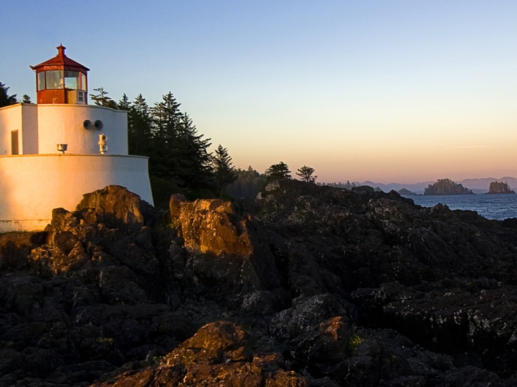
Figure 1 Picturetext headline
Picture text is better placed under the picture, (the width of the picture above is 12,9 cm, the space between the margins)

Image librarys
https://pixabay.com
https://medpix.nlm.nih.gov

Convert vector to pixel
https://convertio.co/vector-converter/

Tables
Tables are easily created in the Word file. To make tables consistent, use the following formats:
- Table text headings
- Table text in table
- Table text (for notes)
Tabel 1. Tabeltext headline
OBJECT | NEED
Format:Tabletext in table | 1
Newsapaper | 3
Notebooks | 1
Penn | 3
Scissor | 1 st.
Tabeltext is better placed below the table, for notes…

Numbered headlines
- Mark the first headline in your document
- Click start
- Click multi-level list
- Choose the list as picture below
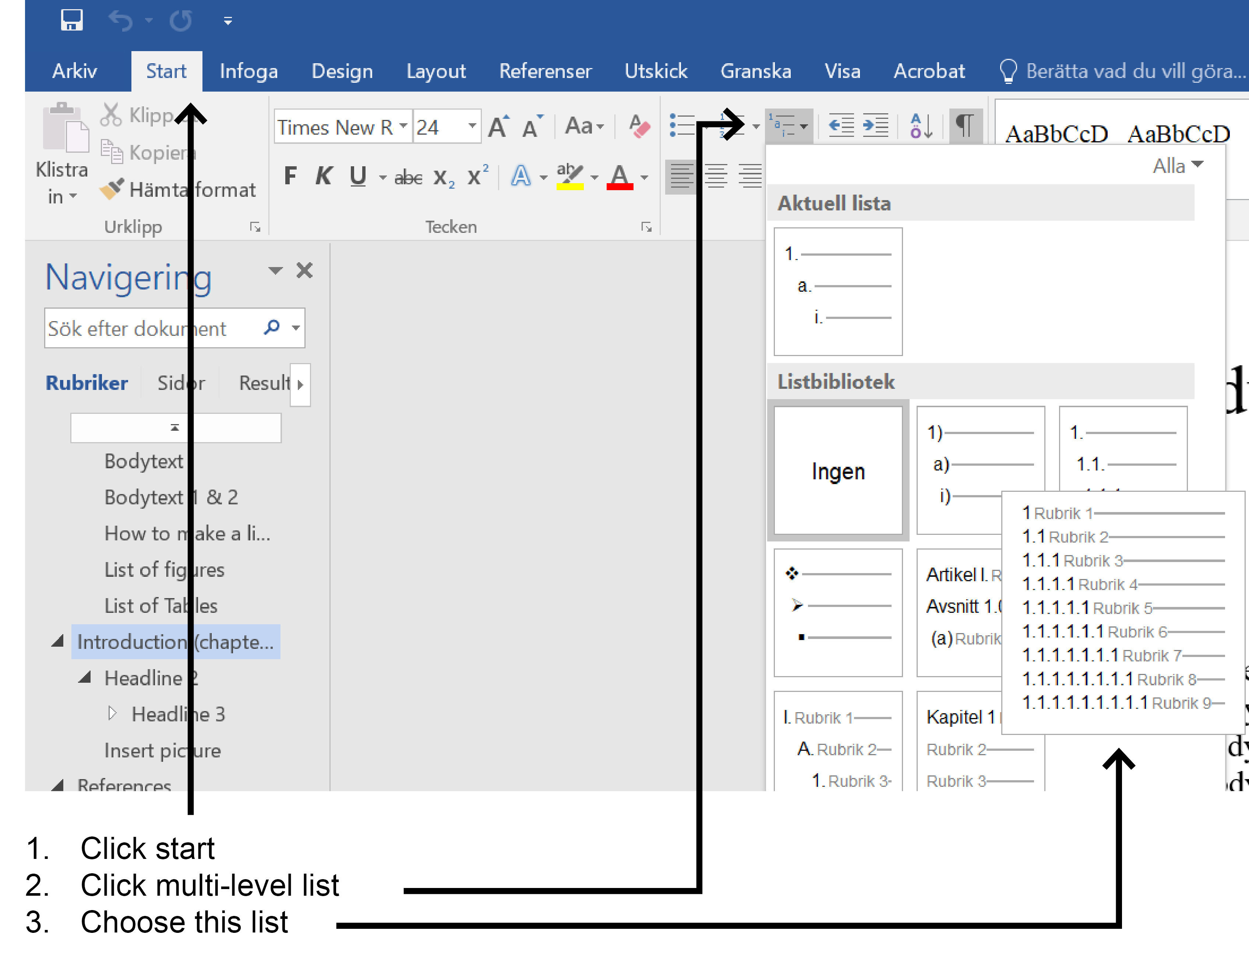

Make your texts accessible
To make your text accessible to people with disabilities, the PDFs that we upload must be accessibility-adapted. The law on accessibility of digital public documents has been in effect since January 1, 2019, and means, among other things, that PDFs need to be readable by for example electronic screen readers. Follow the instructions below to make your documents accessible.
- Use format and layout settings
- Write alternative texts for images
- Use the table tools
- Use the Word Accessibility Checker

Alternative texts for images
An alternative text must describe the image concisely – aim for a maximum of 125 characters. The amount of detail depends on the importance of the image. Focus mainly on those readers that cannot see the image.
Describe what type of image it is, for example a photo or an illustration. End with a period, which gives those who use a screen reader a nice pause.
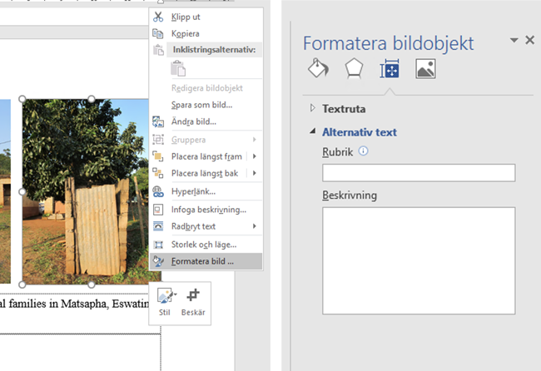
Click on the image, then right click. Choose Format picture from the pop-up list.

Table tools
Try to keep tables simple, preferably with only one level of rows and columns respectively. If the table is complex, consider dividing it into several smaller tables.

Identify table headings
Mark the table and choose the tab Table Design (the tab will only show up if the table is marked).
- If the table has both column headings and row headings, check Header row and First column.
.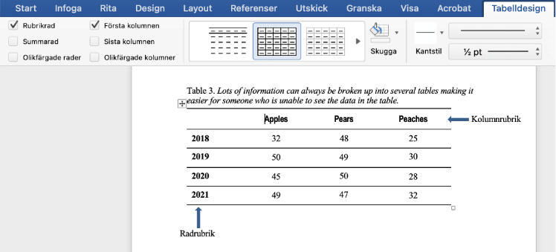
- Add the table name and alternative text in the table properties.
- Describe the table in short. Aim for a maximum of 125 characters. Describe what type of table it is. The importance of the table determines how much detail you should give.
- Focus foremost on those readers that cannot see the table.
- End with a period, which gives those that listen to the screen reader a pleasant pause.

Colours from BTHs graphic profile
BTH HAV – RGB: 5 80 100
BTH SOL – RGB: 240 128 80
BTH HIMMEL – RGB: 154 176 199
BTH SOL ljus – RGB: 247 183 129
BTH HAV ljus – RGB: 123 188 194
BTH BEIGE – RGB: 239 230 224

This is how the footnotes looks like

